Kadijatu Bah

September 23, 2018

Lab 3

**Screenshot:**

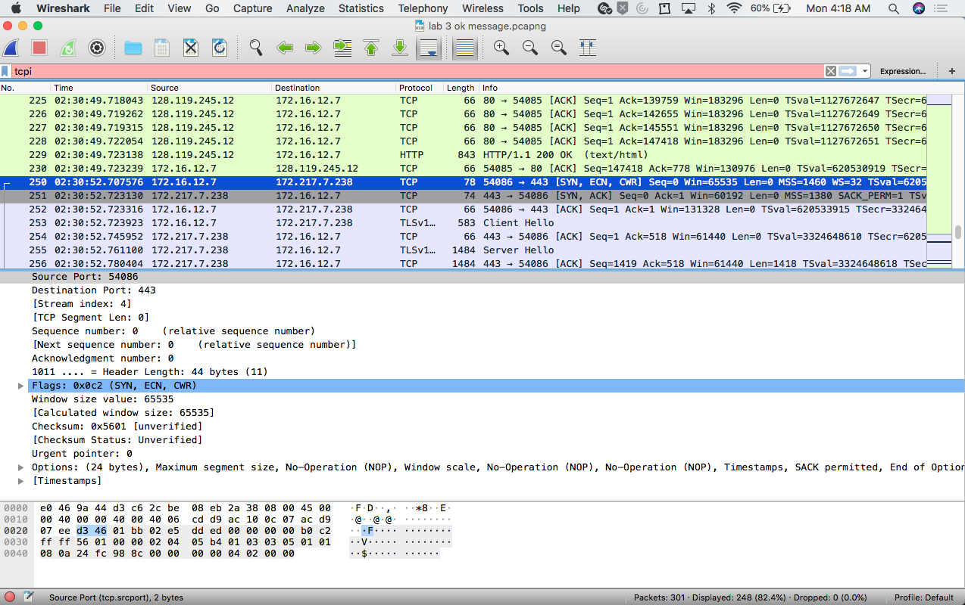

1. What is the TCP port number used by your computer to communicate with gaia.cs.umass.edu?

* **The Tcp port number used is 54085.**

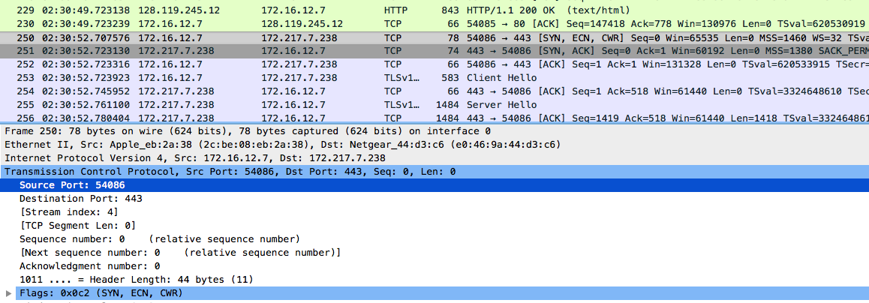

1. What is the TCP port number used by gaia.cs.umass.edu to communicate with your computer?

* **The Tcp port number used is 80.**

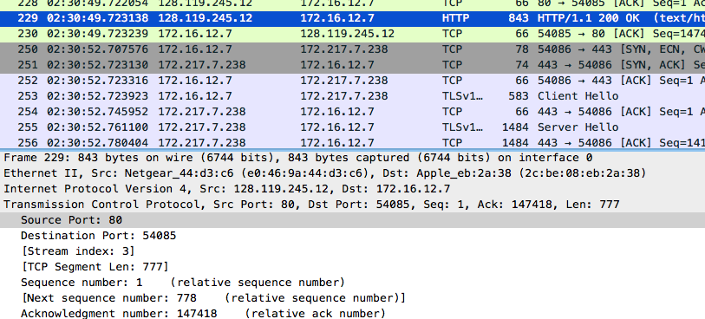

1. What is the sequence number of the TCP SYN segment that is used to initiate the TCP connection between your computer and gaia.cs.umass.edu? What is it in the segment that identifies the segment as a SYN segment?

* **The sequence number is 0. I know because after the ok packet in the information section is says SYN and then seq=0.**

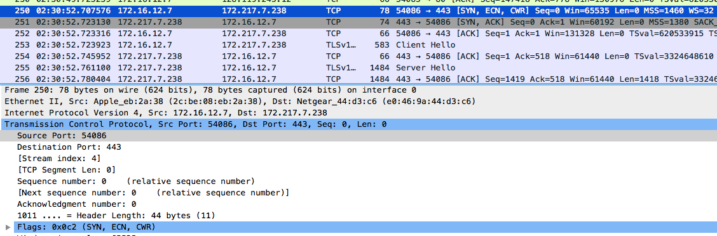

1. What is the sequence number of the SYNACK segment sent by gaia.cs.umass.edu to the client computer in reply to the SYN? - You must dig deep and find the ACK from gaia.cs.umass.edu.

* **The ack number is 1 and the sequence number was 0.**

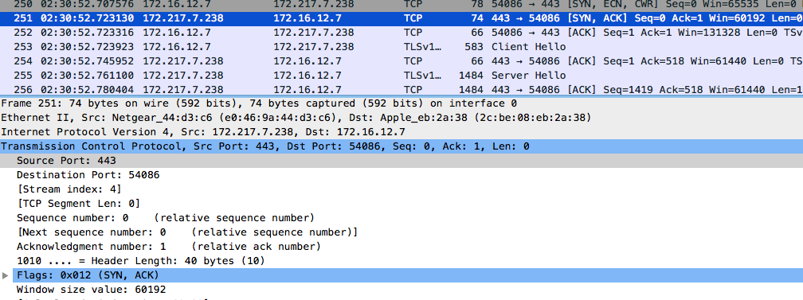

1. What is the sequence number of the TCP segment containing the HTTP POST command? Note: that to find the POST command, you’ll need to dig into thepacket content field at the bottom of the Wireshark window, looking for asegment with a “POST” within its DATA field.

* **The sequence number is 146999.**

